1. 
2. This is the 1st stage of PTLC (Performance Testing Life Cycle).
3. This is very important interview question that what you have to gather for the requirements.
4. The mentor will share some slides in this lecture.   
   If we gather all the info as per instructions in these slides, the mentor is sure there is nothing left to ask the client.
5. The very 1st detail that you gather from the client is the infrastructure detail (Environmental Details).
6. **Like**:
   1. **Overall info**:
      1. How many web servers, how many app servers in PROD and PT Environments?
      2. How many DB Servers are there?
      3. Is there any load balancer?
      4. What is the configuration?
   2. **OS**: What kind of OS is being used?
      1. For servers, we use a flavor of Unix like Solaris.   
         Windows OS is slow.
   3. **Hardware Configuration**:
      1. Number of CPUs?
      2. Their Speed.
      3. Memory.
      4. Network Speed.
      5. **Example**: 1.6 GHz Processor with 32 GB Cache, 16 GB RAM, 100 GB Hard Disk.

Till now we got hardware info whereas Server = Hardware (CPU + RAM + Hard-Disk + OS)+ Softwares installed on those hardwares.  
Now we need to get Software info as Server is a software.

* 1. **Software Support**:
     1. Oracle 10g or Mongo DB, DB2 for DB Server.
     2. WebLogic, Tomcat for App Server.

**NOTE**: We have to gather info/detail for Production and PT environment.

1. Usually, if you ask client about this info, they will redirect you to **Infrastructure Lead** and he will give this all info.  
   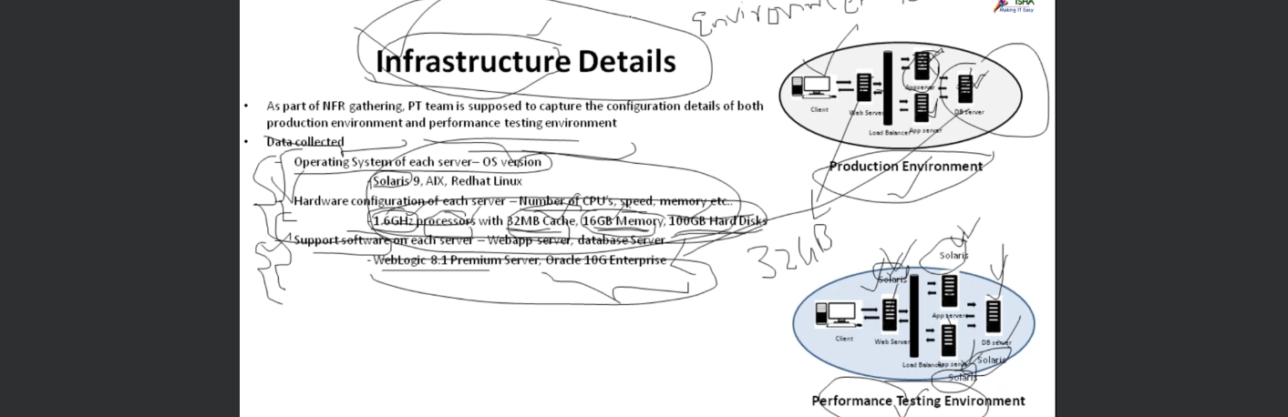  
   So, this is the first NFR that we collect.  
   **What is the 1st NRF**: To collect Infrastructural Detail.

The next thing is Transactional Detail.

1. Let’s understanding what Transactional Detail via an Example is:
2. Suppose we have Gmail app for which we have 1000 Test Cases (for System or Manual Testers) where each test case is a functionality.  
   But for Performance Tester, we don’t consider all of them but may be 100 of 1000 test cases.
3. So, what we will do, we will filter for **Performance Critical Transactions**.
4. Manual/System Testers use the term **Test Cases** whereas Performance Tester uses the term **Transaction**.
5. But how to identify the test cases out of 1000 which we can use in Performance Testing.  
     
   Let’s try to understand by a practical Example.
6. 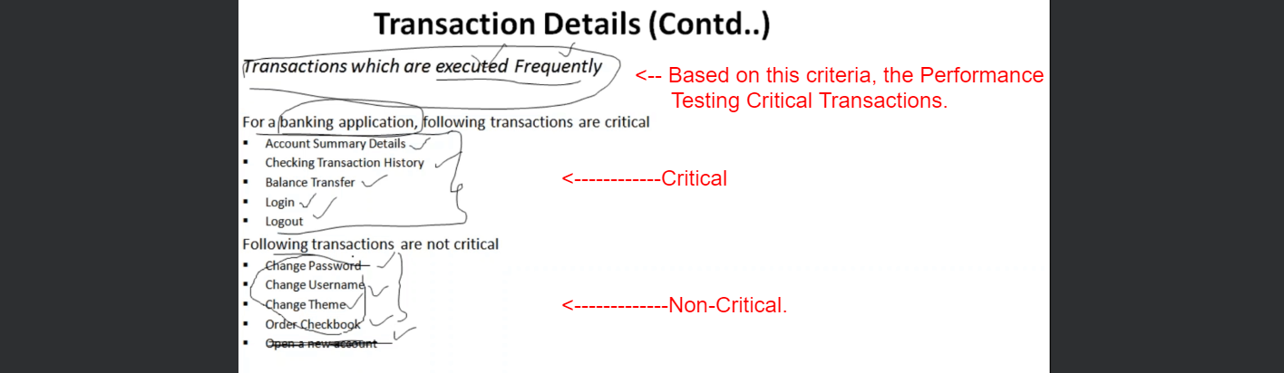  
   If you ignore the non-critical transactions, this is a challenge from you the client.   
   They (Clients) will come back and say that these transactions (non-critical) will create some sort of load on the servers if not much, so what is your **mitigation plan**.  
   So, we have to give a satisfactory answer like there are thousands of transactions and we can not do PT for each transaction type as it will take long time, money etc.
7. Another Category of transactions which are performance critical transaction.  
   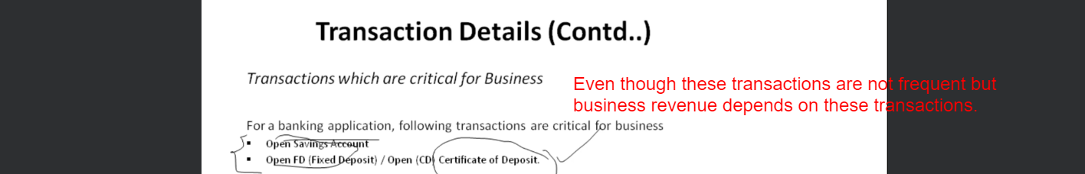
8. Another Category of transactions which are performance critical transaction.  
   